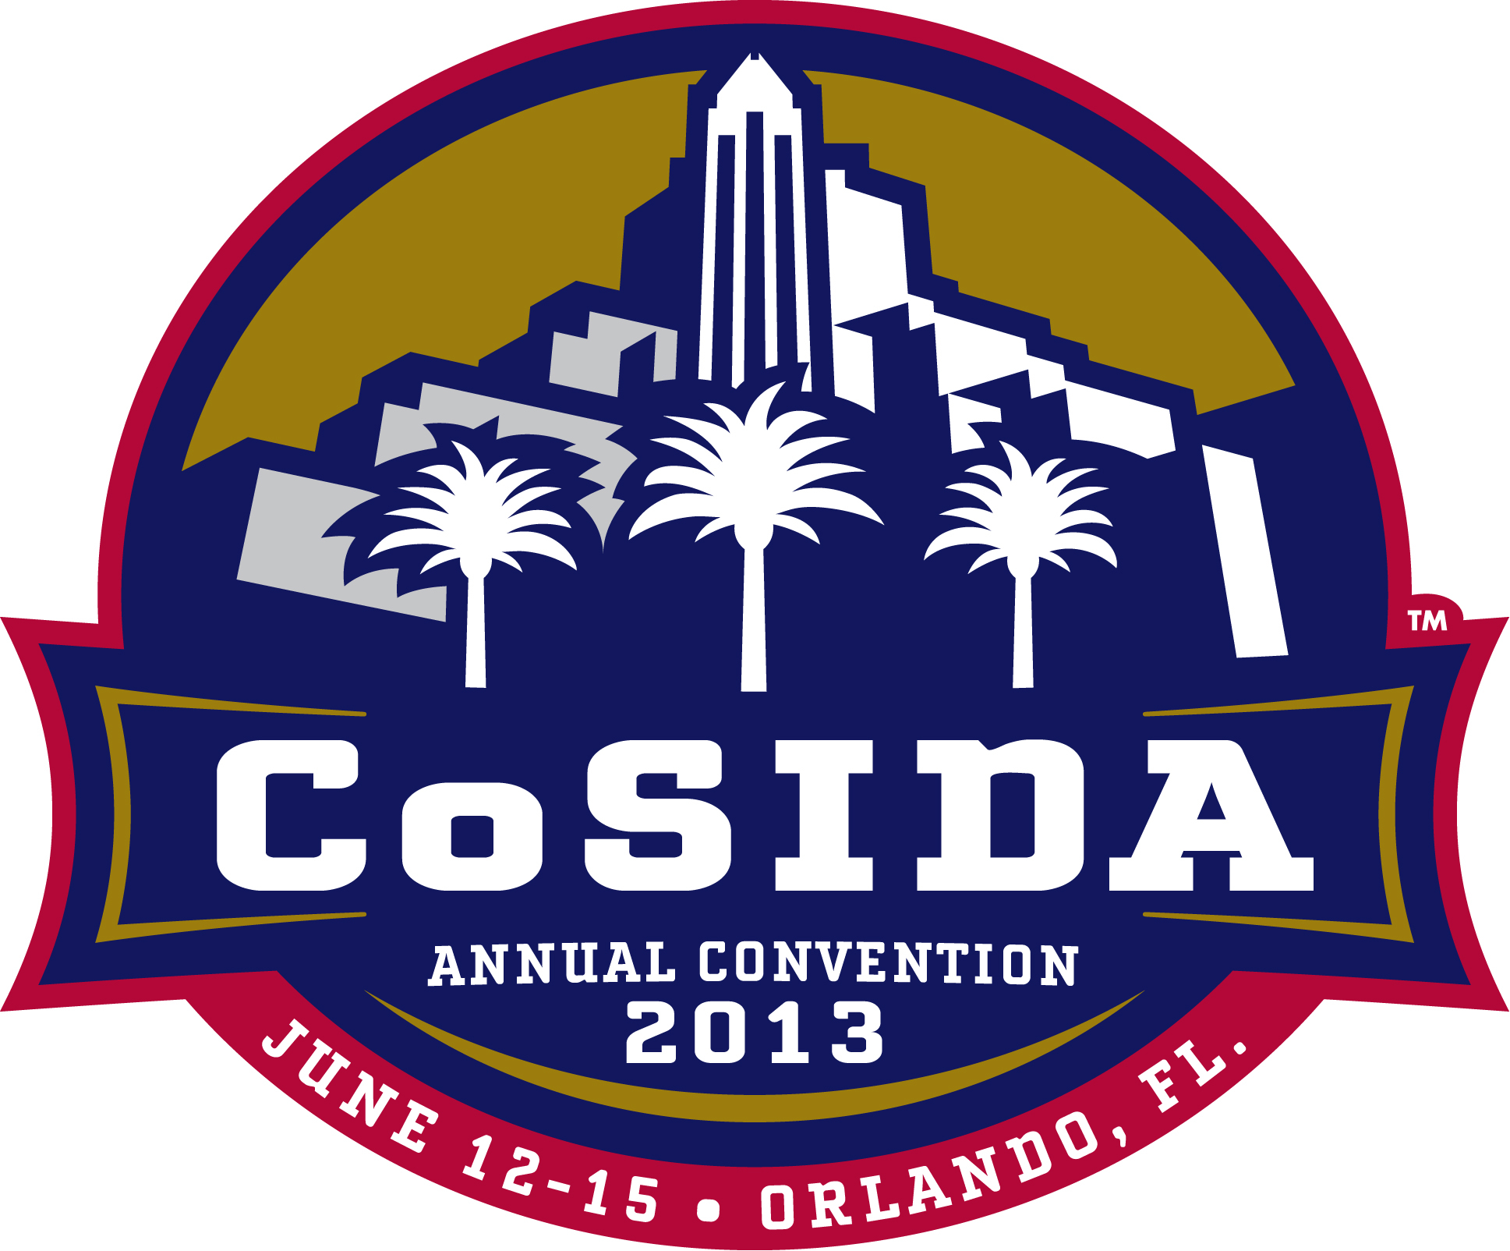
Why Attend the 2013 CoSIDA Convention?
Wednesday-Saturday
June 12-15, 2013
World Center Marriott, Orlando, Fla.

CoSIDA’s annual Convention, workshop sessions and networking opportunities are designed to help you think and grow as a professional. Our CoSIDA Conference is designed to make athletic communicators “think together”.
In 2013, CoSIDA joins the NACDA & Affiliates Convention in Orlando, which presents the highest level of networking and joint programming opportunities in CoSIDA convention history.
Justifying your conference attendance to management can be challenging. With the current economy and athletic department cutbacks in professional development travel, much discussion is focused on the legitimacy of attending conferences.

The reality: conferences are among the most cost-effective methods to obtain education, information, networking opportunities, and professional connections; discuss real-world communications concerns; share best practice information. Given all the constraints on our time and money, these are key reasons that make conference attendance worthwhile.

The 2010 San Francisco Convention, 2011 Marco Island (Fla.) Convention and 2012 St. Louis Convention created great buzz among participants and presenters with a tremendous strategic and digital communications-based workshop program great settings. And, in the last three-plus years, we have shattered our annual membership totals and now have a record membership close to 2,800.

There is great momentum within our national organization, and opportunities exist year-round for professional development … help us carry this momentum to Orlando for the June 2013 national workshop! You will be

challenged to consider new ideas, new strategies, new technologies. That’s an invaluable investment towards your growth as an athletic communications professional.

When that happens, you will leave feeling energized, invigorated, and inspired.

The 2013 CoSIDA Convention which is part of the NACDA & Affiliates Convention gives you the best opportunity to:

* Incorporate the ideas and information shared into becoming a better “intercollegiate athletic strategic communicator” in today’s challenging and always-changing times – and hear from many experts in the process
- Anticipate and adapt to the challenges of tomorrow's opportunities
- Help build an organizational culture that allows for continued success in our profession
- Refresh your analytical skills and update your professional toolkit
- See case studies and best practices from communications and athletic management leaders
- Meet the top communicators in our field, top collegiate athletic leaders and national figures. Ask them what keeps them motivated and rejuvenated on the job and glean valuable insight on their journey to the top. The conference is your golden opportunity to cultivate relationships with these industry leaders – what could be more motivating than that?
- Working with other NACDA management groups as we co-host panels and breakout sessions, expand your knowledge base, improve your personal skills and network. See what your peers are doing, what are new trends in the industry, and where there’s room for movement and improvement.
- Participate in these break-out sessions specifically designed to stimulate your personal and professional growth. These will help you increase your ability to step up as a leader, influence others through powerful communication skills and develop a personal brand that is distinctly your own while vastly improve your chances for success.
- Focus on your critical NCAA/NAIA/CIS/NJCAA divisional issues and attend breakout sessions with a special focus on these divisional issues
- Join our special luncheons and inducation ceremonies to recognize CoSIDA Hall of Fame, Capital One Academic All-America Hall of Fame and other Special Award honorees.
- Use the job placement services via the CoSIDA Career Center and Job Seekers Committee job boards and on-site interviews.
- Attend the annual business meeting.
- Interact with the Board of Directors and divisional representatives to discuss CoSIDA programs, affairs, concerns, and future meetings.
- Join in social events, both planned and informal. Some of these will be CoSIDA-members only and others will be with our peers from marketing, fundraising, development and other senior athletic leaders in attendance at the NACDA & Affiliates convention.
- Carry out an important personal professional role – be a “participant” within your professional group
- The convention provides a wonderful opportunity for you to not only receive the benefits of being there but also provides you the opportunity “ to give” as well to your colleagues and profession.

The Convention is AFFORDABLE

CoSIDA recognizes that membership resources vary from campus to campus, office to office, division to division. Annually, the CoSIDA Conference, with its high quality and interactive programming, is arguably the most-affordable national conference in intercollegiate athletics. Other conferences in athletics cost upwards of 2-3 times the amount that the CoSIDA conference does.
Our Board of Directors works diligently to help keep the CoSIDA registration fee affordable for everyone. The 2013 pre-registration fee remains the same as last two years - $195.00 for CoSIDA members. This is the lowest among all the collegiate associations- by $100 dollars. Those registering with NACDA will pay substantially more in Orlando.
- Enjoy the beautiful award-winning Orlando World Center Marriott – in a vibrant Orlando area.

Enhance Your Leadership Skills
- Get multiple perspectives on leadership in workshop sessions
- Conduct an interactive workshop session in the table topic format or at the digital technology summit. Present before your peers and share your interest and expertise
- Plan, coordinate and serve on a panel
- Serve on a CoSIDA Committee and meet during the Convention to review year-long goals and objectives and set new agendas for the next academic year

Connect and Learn with Your Peers
- Be among the thousands of CoSIDA and NACDA & Affiliate participants from diverse institutional and regional backgrounds
- Convention maximizes interactivity with a high ratio between speakers and participants and with breakout sessions for small-group work and discussion
- Network, network, network. Meet experts and colleagues to share tips to solve real-world communications issues and problems.

Enjoy the Orlando Experience
- Interact and socialize with leaders, colleagues and friends in a beautiful hotel setting within numerous first-class amenities and activities with the popular Orlando entertainment and attractions close by. Take time to tour and to gain impressions of the region and city of our conference. Recent cities like San Antonio (2009), San Francisco (2010) and St. Louis (2012) were wonderful urban areas to visit. Our time on the ocean at Marco Island (2011) was unlike any other Convention location we’ve had. Now, we return to Orlando which was the site of our most popular CoSIDA Convention in history years ago.
- In your free time, enjoy the sprawling hotel indoor and outdoor amenities, shopping, and a great entertainment district nearby with Disney and other world-renown attractions. Gather indoors and outdoors to enjoy CoSIDA informal and social outdoor receptions and gatherings.

Excellent Networking Opportunities
CoSIDA conferences are attended by people all over North America representing college and university institutions and organizations. Take the time to meet new people and enlarge your circle of professional connections.

This is an excellent opportunity to find out what others are doing, obtain tips, troubleshoot problems, bounce ideas around, and make friends so that when you go back home you've extended the number of people you can collaborate with. There are endless opportunities to talk to other athletic communicators who face the exact same problems as you do. As you learn from others, you can form networks of people to talk with throughout the year.

Diverse Workshop Programming and Content
There's content for everyone! We've got presentations for newbies, experienced communications leaders, assistant directors and Assistant ADs, who come from small and large schools, public and private. From presentations on management styles, leadership, crisis and strategic communications, digital

communications, social media tools and tactics, you'll find something you can take back and use in your everyday work.

Hear inspiring Keynote Presenters
The CoSIDA Convention has a tradition of impressive keynote presentations and speakers who are industry leaders. Recent keynote presentations were given by former NCAA President Myles Brand, former White House press secretaries and strategic/crisis communication experts Kevin Sullivan (2009) and Ari Fleischer (2010) while noted football coaching legend and motivational speaker Lou Holtz (2011) addressed a standing-room only crowd in Marco Island.

Meet leaders in the field.
Shake hands, listen, exchange contact information. Meet the current and previous Presidents of the organizations, national athletic figures, speakers, presenters, CoSIDA leaders and our special guests and presenters who are leaders in intercollegiate athletics. These are the people who set the tone and tenor for our industry.

Share Like Experiences
CoSIDA meetings, sessions and social opportunities offer you the ultimate in networking and learning - the opportunity to exchange information, ideas, and perspectives in person, face to face, with your colleagues, sponsors and key presenters from PR and athletic leaders.

Innovative & diverse workshop programming, focusing on communications best practices and professional development
- Innovative programming: learn firsthand from industry experts in communications/journalism, writing, leadership, social media strategy
- Hear from national athletic leaders (AD’s, NCAA, NAIA senior leaders and representatives) and noted speakers from business, entertainment and the like as they discuss global and national communications issues, review the role, challenges and expectations facing athletic communicators while offering solutions and assistance to help us with our every day concerns
- Interact with peers who share many of your same challenges and goals
- Keep up to date on new and emerging technologies
- Get immediate answers and solutions to issues within your organization (staffing, budget, time management, strategic communications, crisis communications, how to keep abreast of the social media/digital media explosion)
- Discover new products that can decrease expense, assist in raising awareness and exposure for your program/student-athletes and increase marketing revenue
- Walk away with “action ideas” that you can immediately implement once you return to work

The Exhibitor Trade Show
Making personal connections with the exhibitors is another huge benefit to attending the conference. One quick conversation could solve what you’ve been trying to resolve for months. Attendees can get free trials and hands-on training resources, learn about the latest technology software and hardware, and meet people they had previously only dealt with by email or phone.

- See the latest in technology and take part in hands-on demonstrations
- Hear new product announcements
- Get answers directly from CoSIDA sponsors and vendors on the exhibition floor
- Do some comparison shopping; compare products side-by-side in the exhibitor area
- Seek solutions and find new technologies
- Talk with others who are using or considering a product or service you are researching

Who Should Attend?
Everyone. There is something for every athletic communicators, regardless of your level of experience and tenure.

Again, the CoSIDA Convention is affordable and gives you a tremendous content-to-amount-paid ratio.

There's plenty of content for all levels of athletic communications to learn and apply … You also might find that another organization is doing something similar to what you're doing and collaborate.

TOP FIVE reasons why you would send staffers to the Convention:

- Chances are very good it will make them better athletic communicators
- It’s an event that inspires members. There are constant opportunities for professional growth; to enhance your department, your athletic communicator will benefit from this experience, especially after a rigorous academic year and heavy workload
- It’s an event where athletic communicators learn about the best practices that work on like campuses and conferences, about relevant surveys, research and trends, and have opportunities for hands-on learning and training
- Attendees share what they learned with other CoSIDA members and NACDA attendees during the conference and after the conference.
- Networking, networking, networking!

Be a part of the solution! Create a stronger future for yourself, your department, institution or conference by attending the 2013 CoSIDA Orlando Convention!

