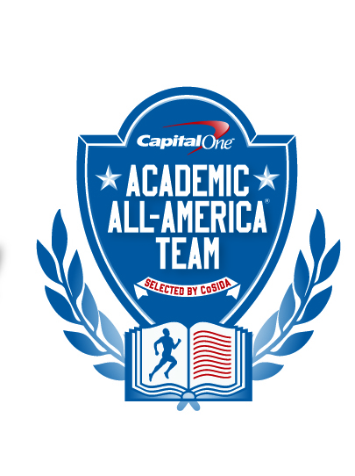

Capital One Academic All-America® Team

Selected by CoSIDA
FOR RELEASE: Tuesday, August 6, 2013 – 12 noon (EDT)

Please visit the Capital One Academic All-America® website http://www.capitaloneacademicallamerica.com/

COLTON HUNT OF RANDOLPH NAMED AS CAPITAL ONE DIVISION III ACADEMIC ALL-AMERICA® OF THE YEAR
TOWSON, Md. – Senior Colton Hunt of Randolph College, who led the Randolph College men’s basketball team to a 21-7 record and an NCAA Division III Tournament appearance, has been named as the Capital One Division III Academic All-America® of the Year, as selected by the College Sports Information Directors of America (CoSIDA).
The Capital One Division III Academic All-America® program is being financially supported by the NCAA Division III national governance structure to assist CoSIDA with handling the awards fulfillment aspects for the 2012-13 Division III Academic All-America® teams program.
An economics major who graduated with a 3.95 G.P.A. with minors in finance and physics, Hunt graduated first in his class at Randolph.
As a senior, he was the third-leading scorer in NCAA Division III, averaging 24.2 points per game. He also averaged 7.3 rebounds and 3.0 assists per game while leading the Wildcats of Coach Clay Nunley to a 21-7 record and their first-ever NCAA Division III post-season appearance,
The winner of the 2012-13 Josten’s trophy, Hunt earned first team All-American honors from the National Association of Basketball Coaches and D3hoops.com. Honored as the NABC South Region Player of the Year, he was named as a first team All-Old Dominion Athletic Conference selection three times. A native of Whittier, N.C., Hunt was the ODAC Player of the Year as a senior.
Hunt finished his career as Randolph’s career leader in points (1,878), scoring average (17.4), field goals made (639), assists (264) and steals (251). He was also second on the Wildcats’ career list with 630 rebounds.
Honored as Randolph College’s Male Athlete of the Year, Hunt was also the winner of the Doc Jopson Award, presented to the top scholar-athlete in the ODAC.
The Capital One Academic All-America® of the Year award winners in the other divisions will be announced this week.
On Wednesday, August 7, the Capital One Division II Academic All-America® of the Year award winner will be announced. The Capital One Division I Academic All-America® of the Year award winner will be named on Thursday, August 8.

About Capital One
Capital One Financial Corporation (www.capitalone.com) is a financial holding company whose subsidiaries, which include Capital One, N.A. and Capital One Bank (USA), N. A., had $216.5 billion in deposits and $294.5 billion in total assets outstanding as of March 31, 2012. Headquartered in McLean, Virginia, Capital One and ING Direct offer a broad spectrum of financial products and services to consumers, small businesses and commercial clients through a variety of channels. Capital One, N.A. has approximately 1,000 branch locations primarily in New York, New Jersey, Texas, Louisiana, Maryland, Virginia and the District of Columbia.
A Fortune 500 company, Capital One trades on the New York Stock Exchange under the symbol "COF" and is included in the S&P 100 index.
Capital One, an NCAA Corporate Champion, began its affiliation with college sports with the sponsorship of the 2001 Capital One Florida Citrus Bowl (now the Capital One Bowl) and ESPN’s Capital One Bowl Week. In addition, Capital One sponsors the ABC College Football Halftime Report, Capital One All-America Mascot team, Capital One Academic All Program, and supports all 89 NCAA Championships including the Division I Men’s and Women’s Basketball Championships, and numerous other collegiate athletics programs.
To be eligible for Academic All-America® consideration, a student-athlete must be a varsity starter or key reserve, maintain a cumulative G.P.A. of 3.30 on a scale of 4.00, have reached sophomore athletic and academic standings at his/her current institution and be nominated by his/her sports information director.
Since the program’s inception in 1952, CoSIDA has bestowed Academic All-America honors on more than 20,000 student-athletes in Divisions I, II, III and NAIA, covering all NCAA championship sports.
For more information about the Academic All-America® Teams program, please visit www.cosida.com

2012-2013 CAPITAL ONE SPORT-BY-SPORT
DIVISION III ACADEMIC ALL-AMERICA® OF THE YEAR
AWARD WINNERS

Name Sport Cl. Hometown Major, G.P.A.
Nate Bascom, Ohio Northern M. Soccer Sr. Maderia, Ohio Biology, 3.71
Nick Driskill, Mount Union Football Sr. Wabash, Ind. Exercise Science, 3.77
Elaine Gerry, Edgewood W. Soccer Sr. Prairie du Sac, Wis. Accounting, 3.95
Teal Gove, Plattsburgh State W. At-Large Sr. Berwick, Ont., Can. Biology, 3.83
Mackenzie Griffin, John Carroll Softball Sr. Lake Oswego, Ore. Communications, 3.72
Colton Hunt, Randolph College M. Basketball Sr. Whittier, N.C. Economics, 3.95
Lizzie Kamp, Calvin College Volleyball Sr. Orland Park, Ill. Accounting, 3.69
Mary Mahoney, Mount Union W. Track, CC Sr. Ashtabula, Ohio Environmental Science, 3.97
* Tim Nelson, Wisconsin-Stout M. Track, CC Sr. Augusta, Wis. Business Administration, 3.70
Curtis Ramsey, Kenyon College M. At-Large Sr. Wilmington, Del. Economics, 3.91
Brendan Toughey, Baldwin Wallace Baseball Sr. East Amherst, N.Y. Master’s of MBA in Accounting, 3.93
Carissa Verkaik, Calvin College W. Basketball Sr. Holland, Mich. Elementary Education, 3.76
* repeat selection

FOR MORE INFORMATION:
Dan O’Connell, Towson University (doconnell@towson.edu) (410) 704-3102
Academic All-America ® Vice-Chair for Publicity/Communications

